**ULTRA GRIPPER PRODUCT SPECIFICATIONS**

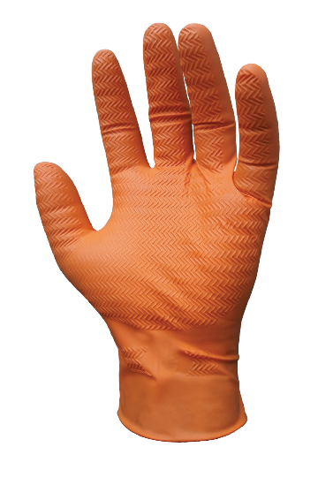

**Name of Product** :

**Name of Manufacturer** :

**Base Material**  :

**Characteristics** :

**Available Sizes** :

**Surface** :

**Surface Treatment** :

**Colour**

**Physical Specifications:**

|  |  |  |  |  |  |  |  |
| --- | --- | --- | --- | --- | --- | --- | --- |
| Size | Length  (mm | Thickness(±0.01) mm  SINGLE WALL | | | | | Width (mm) |
| Tip | | Palm | | Cuff |
| Smooth Surface | Textured Surface | Textured Surface | Smooth Surface | |
| Small | 240±5 | 0.19±0.01 | 0.28±0.01 | 0.23±0.01 | 0.11±0.01 | | 85±5 |
| Medium | 240±5 | 0.19±0.01 | 0.28±0.01 | 0.23±0.01 | 0.11±0.01 | | 95±5 |
| Large | 240±5 | 0.19±0.01 | 0.28±0.01 | 0.23±0.01 | 0.11±0.01 | | 105±5 |
| X Large | 240±5 | 0.19±0.01 | 0.28±0.01 | 0.23±0.01 | 0.11±0.01 | | 115±5 |
| XX Large | 240±5 | 0.19±0.01 | 0.28±0.01 | 0.23±0.01 | 0.11±0.01 | | 120±3 |

**Tensile (ASTM D 6319 & EN 455-2)**

|  |  |  |
| --- | --- | --- |
| **Tensile(MPA)** | **Elongation(%)** | **Force At Break(N)** |
|  |  |  |

**Quality Assurance**

|  |  |
| --- | --- |
| **Visual Inspection G-I AQL** | **Physical dimension S-II AQL** |
| **Leak Test G-I AQL** | **Physical Properties S-II AQL** |

**International Compliances:**

* CE:
* Sizing, Dexterity & Mechanical Attribute:
* Innocuousness & PH:
* Microbial Penetration & chemical Permeation:
* Food Safe Application:

**Total Residue Content**  - < 2.0 Milligrams per glove

**Packaging (Normal)**  - 100±2 pieces in one Dispenser Box,10 Dispenser Box in one Carton

**Labeling on Dispenser (Normal)** - Product Name, Size, Lot no. Quantity, Manufacturer’s address, Warning about Nitrile

Allergy

**Labeling on Carton (Normal)** - Product Name, Size, Lot no. Quantity,Country of Origin.

**Container Loadability** (No MOQ in manufacturer owned brand in standard Packaging)

20FCL=800 Cases,40 FCL=1600 Cases,40FCL-Q=1900 Cases.

**Protection Gear**

**Protection from Penetration of microorganisms:**

Performance Level**:**

AQL

Inspection Levels:

**Protection from permeation to Hazardous chemicals:**

Sodium Hydroxide 40%:

96% Sulphuric Acid :

Formaldehyde 37%:

25% Ammonia :

Glutaraldehyde 4%:

Hydrogen Peroxide 3%:

Formalin 10%:

n-Heptane :

**App Versatility**: